Session 2026-2027

Vision:Dream of where you want. | Mission: Means to achieve Vision

Program Educational Objectives of the program (PEO): (broad statements that describe the professional and career accomplishments)
PEO1 | Preparation | P: Preparation | Pep-CL abbreviation  pronounce as Pep-si-lL easy to recall
PEO2 | Core Competence | E: Environment (Learning Environment) | Pep-CL abbreviation  pronounce as Pep-si-lL easy to recall
PEO3 | Breadth | P: Professionalism | Pep-CL abbreviation  pronounce as Pep-si-lL easy to recall
PEO4 | Professionalism | C: Core Competence | Pep-CL abbreviation  pronounce as Pep-si-lL easy to recall
PEO5 | Learning Environment | L: Breadth (Learning in diverse areas) | Pep-CL abbreviation  pronounce as Pep-si-lL easy to recall

Program Outcomes (PO): (statements that describe what a student should be able to do and know by the end of a program)
Keywords of POs:
Engineering knowledge,Problem analysis, Design/development of solutions,Conduct Investigations of Complex Problems, Engineering Tool Usage, The Engineer and The World,Ethics, Individual and Collaborative Team work,Communication, Project Management and Finance, Life-Long Learning

PSO Keywords: Cutting edge technologies, Research

“I am an engineer, and I know how to apply engineering knowledge to investigate, analyse and design solutions to complex problems using tools for entire world following all ethics in a collaborative way with proper management skills throughout my life.” to contribute to the development of cutting-edge technologies and Research.

Integrity: I will adhere to the Laboratory Code of Conduct and ethics in its entirety.

Name and Signature of Student and Date
(Signature and Date in Handwritten)

Session | 2026-27 (ODD) |  | Course Name | Web Technology Lab
Semester | 3 |  | Course Code | 23CT1301
Roll No | 72 |  | Name of Student | Yash Nikhad
Practical Number |  | 7
Course Outcome |  | - Understand various internet technologies.  - Design the web pages using HTML and CSS.  - Implement the XML technology to store the data.  - Develop the interactive web pages using JavaScript.
Aim |  | JavaScript — Asynchronous Programming (Fetch/Promises)
Problem Definition |  | Build a small Weather App or Movie-Search App that fetches  data from ONE public API using fetch()/async-await and renders it dynamically.
Theory  (100 words) |  | JavaScript asynchronous programming relies on Promises to handle operations that take time, such as network requests via the Fetch API, without blocking the main thread. The fetch() method returns a Promise that resolves to a Response object, allowing developers to chain .then() and .catch() methods or use the cleaner async/await syntax to wait for results.  Using Async/Await simplifies code readability by pausing execution until the promise resolves, enabling standard try...catch error handling. To perform parallel requests, developers use Promise.all() to wait for multiple fetch calls to complete simultaneously, which is more efficient than sequential requests.  Key Concepts:  - Promises: Objects representing the eventual completion or failure of an async operation.  - async Functions: Always return a Promise; allow the use of await.  - await: Pauses function execution until the Promise settles, available only inside async functions.  - Promise.all(): Returns a single Promise that resolves when all input Promises resolve, or rejects if any fail.
Procedure and Execution  (100 Words) |  | Step 1: Create the JavaScript file  Step 2: Create the shopping cart  Step 3: Implement the Add operation  Step 5: Implement product-name extraction  Step 6: Calculate the total price  Step 7: Add a new product  Step 8: Remove a product  Step 9: Display product names and total  Step 10: Execute the program
Code : Javascript
let cart = [
{ id: 1, name: "Laptop", price: 50000, quantity: 1 },
{ id: 2, name: "Mouse", price: 800, quantity: 2 },
{ id: 3, name: "Keyboard", price: 1500, quantity: 1 }
];
function addToCart(product) {
cart.push(product);
}
function removeItem(id) {
cart = cart.filter(product => product.id !== id);
}
function getProductNames() {
return cart.map(product => product.name);
}
function calculateTotal() {
return cart.reduce(
(total, product) => total + product.price * product.quantity,0);
}

console.log(“Initial Cart:”);
console.log(cart);
addToCart({
id: 4,
name: “Headphones”,
price: 2000,
quantity: 1
});
console.log("\nCart after adding Headphones:");
console.log(cart);
removeItem(2);
console.log("\nCart after removing Mouse:");
console.log(cart);
console.log("\nProduct Names:");
console.log(getProductNames());
console.log("\nTotal Price: ₹" + calculateTotal());
 |  | 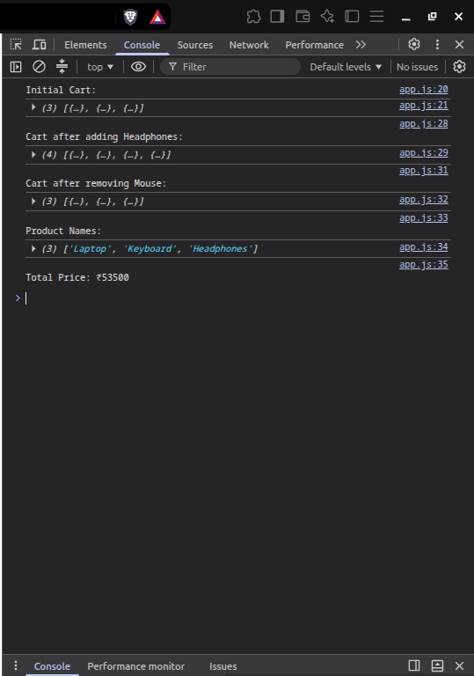
Output Analysis |  | The JavaScript program successfully models a shopping cart using an array of objects and demonstrates the use of push(), map(), filter(), and reduce() to add products, remove products, retrieve product names, and calculate the total price.
Link of student Github profile where lab assignment has been uploaded |  | https://github.com/YashNikhad
Conclusion |  | Successfully studied the arrays and higher order functions of JavaScript and demonstrated built a client side application.
Plag Report (Similarity index < 12%) |  | 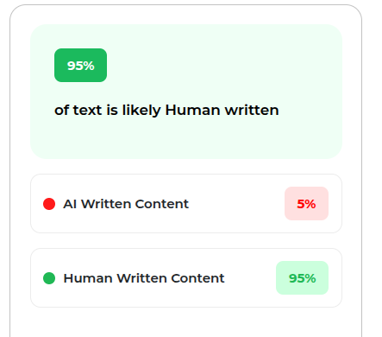
Date |  | 05/10/2026

